**CHAPTER 1**

**INTRODUCTION**

**1.1 Introduction**

Gesture-based control of robotic hands enables users to communicate and control robots through natural hand gestures. This innovation enhances the human-machine interaction. This intuitive interface allows for more flexible and responsive robotic movements which impact various sectors such as industrial automation and assistive technologies.

The technology finds diverse applications from manufacturing for hands-free robotic arm control to healthcare for more natural prosthetic limb interaction. This versatility highlights the broad impact and potential of mimicking a robotic hand using gesture recognition in different industries. Gesture-based control of robotic hand is a significant advancement in human-robot interaction. The utilization of technologies like computer vision or depth sensing greatly enhances the way users can communicate with and control robots allowing interactions.

Enhanced Human-Machine Interaction enhances the interaction between humans and robots which makes it more user Friendly. Gesture recognition technology enables robots to interpret and respond to subtle hand movements accurately.

In recent years, the integration of artificial intelligence (AI) and robotics has paved the way for innovative solutions in various fields particularly in automation and human-machine interaction. One captivating application that has emerged is the development of AI-driven robotic systems capable of mimicking human hand gestures. This fusion of AI and robotics offers a promising avenue for intuitive and efficient control of robotic arms with implications ranging from industrial automation to assistive technologies.

The concept of gesture control leverages advanced machine learning algorithms to interpret and respond to human hand movements seamlessly. This report explores the implementation and functionality of an AI Gesture-Controlled Robotic Mimicking Hand delving into the technological foundations, design considerations and the potential impact of this cutting-edge technology on diverse applications.

The primary objective of this report is to provide a comprehensive understanding of the underlying principles and practical aspects of an AI-controlled robotic hand that mimics human gestures by bridging the gap between human intent and robotic execution, such systems aim to enhance operational efficiency and contribute to the evolution of intelligent automation.

It is evident that the convergence of AI and robotic technologies holds great promise for transforming industries and redefining the way humans interact with machines. The following sections will provide a detailed analysis of the technological framework, design considerations, and potential applications of AI Gesture-Controlled Robotic Mimicking Hands.

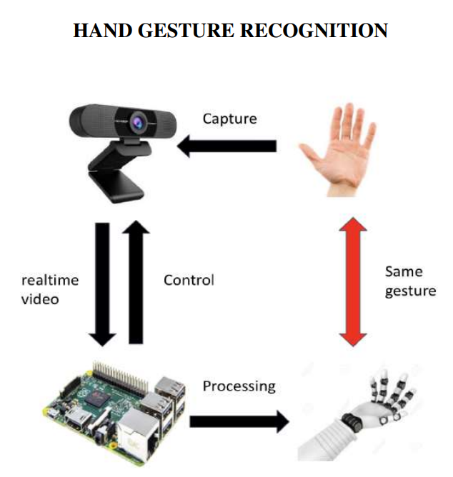

Fig.1.1: Proposed System Development Flow

**CHAPTER 2**

**LITERATURE SURVEY**

**Hande, Shriya et.al**.The project presents a learning Gesture Control Robotic Arm Using Flex Sensor with seven degrees of freedom.The research paper, "Wireless Gesture Controlled Robotic Arm with Vision," introduces a novel system using accelerometers for remote control. Divided into three sections—Accelerometer Part, Robotic Arm, and Platform—the system captures hand and leg gestures via 3-axis accelerometers, transmitting data through RF signals. The robotic arm, with variable degrees of freedom, executes actions like picking and placing objects based on hand gestures. Simultaneously, a mobile platform responds to leg movements for forward, backward, right, and left motions. Vision integration enhances capabilities, possibly utilizing cameras or vision sensors. The wireless communication aspect enables remote operation, making it applicable in various fields, such as industrial automation and medical surgeries. Overall, the system provides a wireless, gesture-controlled robotic solution with vision integration, showcasing potential real-world applications.[1]

**Korayem, M. et**. The feasibility of controlling a surgical robot arm with the attached laparoscopic applicator by the Leap Motion controller has been represented using Kalman Filter.This paper explores the use of the Leap Motion controller as a contact-less user interface for surgical robots, addressing workspace limitations and sterility concerns. The Leap Motion controller tracks hand position, velocity, orientation, and finger gestures, transmitting data to a computer. The received data is then used to control a surgical robot arm, with the system exhibiting low cost, acceptable accuracy (0.1 mm), and high-rate data processing (over 100 fps). The study employs the hand's palm center displacement to control a 5-DOF surgical robot simulator and the angle between the thumb and index finger for laparoscopic grasper manipulation. A robotic experiment demonstrated effective control, with a maximum error percentage of 6.19%. To mitigate system input noises, the paper incorporates a Kalman Filter. Overall, the Leap Motion controller proves to be an efficient, low-cost solution for vision-based, contact-less control of surgical robots.[2]

**Coronadoet.al.**This paper introduces a novel gesture-based robot control framework, presenting adopted design principles and evaluation results with human participants. The use of wearable devices for gesture-based control in human-robot interaction is explored, addressing previously unexplored implications. The paper highlights challenging issues, proposes design guidelines, and offers an open-source implementation utilizing commercially available devices and robots. Performance metrics for the architecture and validation results with 27 untrained volunteers are reported. This research contributes to the understanding and application of gesture-based control in robotics, paving the way for improved human-robot interactions.[3]

**Jayasurya, B., et.al.**This paper delves into the domain of gesture recognition for human-computer interaction, an actively researched area in artificial intelligence and computer vision. The evaluation of gesture recognition performance in real-life environments is addressed, considering cluttered backgrounds, varied poses, and robot movements. The study utilizes skeleton tracking, deriving skeleton data from depth images obtained through a Microsoft Kinect sensor. The Kinect processes and replicates human gestures in 3D space, influencing the robot's actions. An Arduino controller governs the robot's motion, receiving joint angle inputs from the Kinect sensor and feeding them back to the robot circuit for control. The ultimate objective is to develop a gesture recognition system capable of identifying specific human gestures for device control. The resulting gesture-controlled robot is envisioned to significantly reduce labor costs in the future, offering cost-effectiveness and eliminating the need for remote control.[4]

Chaudhary, et.al.The hand-gesture-controlled robotic arm has been built successfully and put to use performing a variety of tasks. Tic-tac-toe, writing, and picking and placing objects were just a few of the activities. The technology worked well in reading hand gestures and performing the necessary tasks.ANN and CNN machine Learning Algorithms are used.[5]

**Guo, Kai, et.al**.This paper introduces a revolutionary solution for addressing the long-term complications of stroke— a wearable rehabilitation glove. Specifically designed for patients with paresis, this motorized glove utilizes soft materials and compact design for ease of use in clinical settings or at home. The glove employs advanced linear integrated actuators controlled by surface electromyography (sEMG) signals to provide assistive force during rehabilitation. It trains individual fingers and all fingers collectively, offering a versatile solution. With 4–5 hours of battery life, the glove incorporates a deep learning algorithm (1D-CNN and Inception Time) to classify hand gestures with an accuracy of 90.89%. This classification serves as a control command for the glove, enabling it to mimic movements based on the theory of mirror therapy and task-oriented therapy. Overall, this wearable rehabilitation glove signifies a significant advancement in stroke rehabilitation, providing a practical and effective solution to alleviate the physical, financial, and social impact of stroke-related complications.[6]

**Sahoo, Jaya Prakash, et.al.**This paper explores the effectiveness of hand gesture recognition as a user-friendly interaction mode between humans and computers. The focus is on developing a real-time, user-independent interface with high recognition performance. Leveraging the success of convolutional neural networks (CNNs) in image classification, particularly AlexNet, VGG-16, and ResNet, a fine-tuning method is proposed. This approach involves pre-training a CNN model and utilizing a score-level fusion technique to recognize hand gestures in datasets with limited labeled images. The method's efficacy is evaluated through leave-one-subject-out cross-validation (LOO CV) and regular CV tests on two benchmark datasets. Furthermore, a real-time American Sign Language (ASL) recognition system is developed and tested, showcasing the practical application of the proposed technique in gesture recognition.[7]

**Haria, Aashni, et.al**.This paper addresses the limitations of physical controllers in human-computer interaction, emphasizing the hindrance to natural interfaces posed by devices like mice and keyboards. The focus is on a designed marker-less hand gesture recognition system capable of effectively tracking both static and dynamic hand gestures. The system translates detected gestures into actions, facilitating tasks like opening websites, launching applications (e.g., VLC Player, PowerPoint), and using dynamic gestures for slide shuffling during presentations. Results indicate that an intuitive human-computer interaction can be achieved with minimal hardware requirements, showcasing the potential for a more seamless and natural interface.[8]

**Hung, Chi-Huang, et.al.**This paper introduces a wearable appliance gesture remote controller, consisting of a hand gesture recognition belt and a receiver unit. Utilizing an accelerometer and gyroscope, the controller discerns hand gestures, with a Kalman filter employed to minimize jitter noise caused by slight hand trembling. The receiver unit decodes the received information and triggers corresponding actions. Notably, the design features an LED array lamp as the controlled home appliance, enabling functions such as on/off and dimming. This innovative system provides a practical and user-friendly solution for remote control, combining motion sensing technology and gesture recognition for enhanced interaction with home appliances.[9]

**Yasen, Mais,et.al.**This study conducts a systematic literature review on hand gesture recognition in Human-Computer Interaction (HCI). Analyzing 560 papers from IEEE Explore (2016-2018), the focus is on identifying techniques, applications, and challenges. Notably, surface electromyography (sEMG) sensors with wearables are commonly used for acquisition, while Artificial Neural Network (ANN) is the prevalent classifier. Applications include sign language interpretation, with background color affecting accuracy. Overfitting in datasets poses a challenge. The study concludes by discussing gesture acquisition, feature extraction, classification, applications, challenges, and the future of hand gesture recognition, introducing recent research from 2016 to 2018. Notable references include "EgoGesture: A New Dataset and Benchmark for Egocentric Hand Gesture Recognition" and "Emerging Wearable Interfaces and Algorithms for Hand Gesture Recognition: A Survey." The review offers insights into recent advancements and future directions in hand gesture recognition.[10]

**2.1 Objectives**

Based on the provided research paper, here are four potential objectives:

* To develop a machine learning algorithm to enable the robotic arm to respond precisely to recognized gestures.
* To design an efficient and real-time system that seamlessly integrates the AI model, gesture recognition, and robotic arm control for user-friendly interaction.
* Implement safety features and error handling mechanisms to ensure the reliable and secure operation of the AI-controlled robotic arm, prioritizing user and equipment safety during interactions.

**CHAPTER 3**

**METHODOLOGY**

**3.1 FLOW CHART**

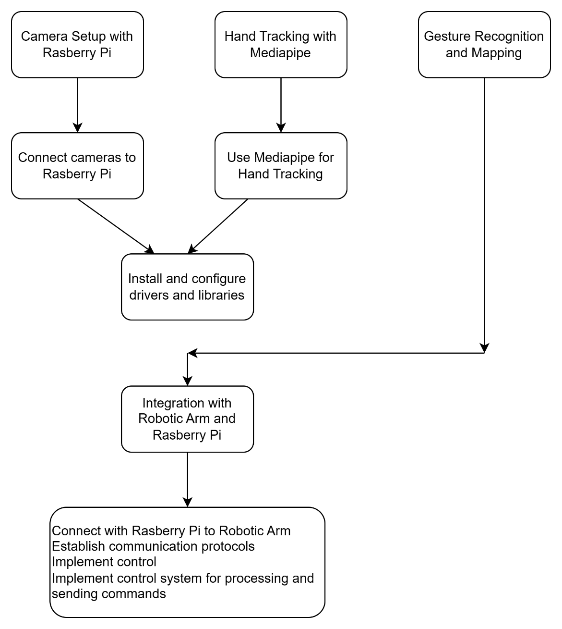

1. Camera Setup with Raspberry Pi:
   1. Connect 2 pi-cameras(5MP) to the Raspberry Pi, ensuring proper installation and configuration.
   2. Implement the necessary drivers and libraries to enable communication between the cameras and the Raspberry Pi.
2. Hand Tracking with MediaPipe:
   1. Use the MediaPipe library to perform hand tracking with the cameras connected to the Raspberry Pi.
   2. Extract hand landmarks and track the movements of the user's hand in real-time.
3. Gesture Recognition and Mapping:
   1. Employ the MediaPipe library for live hand gesture recognition, utilizing the hand landmarks obtained from the hand tracking step.
   2. Develop a mapping algorithm that translates recognized hand gestures into corresponding robotic arm movements.
4. Robotic Arm design using actuators and Arduino: Design a Robotic Arm using actuators making use of Arduino.
5. Integration with Robotic Arm and Raspberry Pi:
   1. Connect the Raspberry Pi to the robotic arm through arduino, establishing communication protocols for data transfer.
   2. Implement a control system on the Raspberry Pi that takes the recognized hand gestures and sends corresponding commands to control the robotic arm's movements.

**3.2 Conceptual Design**

Five servo motors controll the fingers of the robo hand. The motors are driven by an Arduino Uno via a simple custom PCB. The software uses openCV and Googles MediaPipe ML solution to perform hand pose estimation. The servo motors are then controlled according to the fingers positions

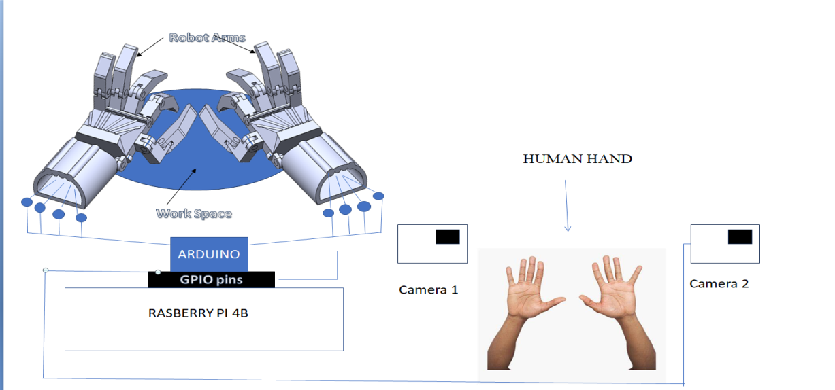

Fig.3.2.1: Pictorial Representation

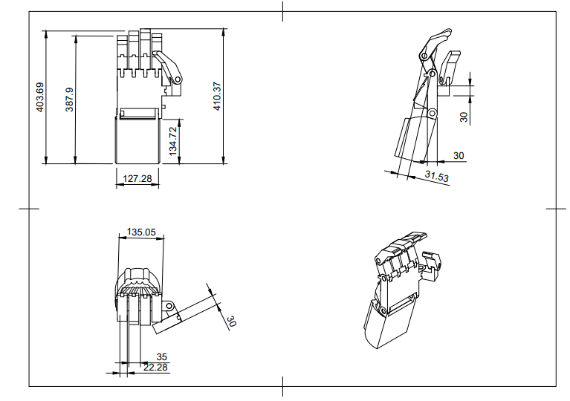

Fig.3.2.2: Drawing with Dimensions of Robotic Arm

**3.3 Materials**

* **Computer(Raspbery Pi):**A computer with sufficient processing power and memory to handle image processing and machine learning tasks efficiently
* **Pi Camera:**A high-resolution camera (e.g., webcam) for recognizing the hand gestures
* **Actuators:** For controlling the robotic arm movements
* **Power supply:**Adequate power source to meet the energy demands of the system
* **Sensors(optional):** Accelerometer and gyroscopes for motion detection
* **Arduino:** Plays a crucial role as a microcontroller or a processing unit

**CHAPTER 4**

**PROJECT GANTT CHART**

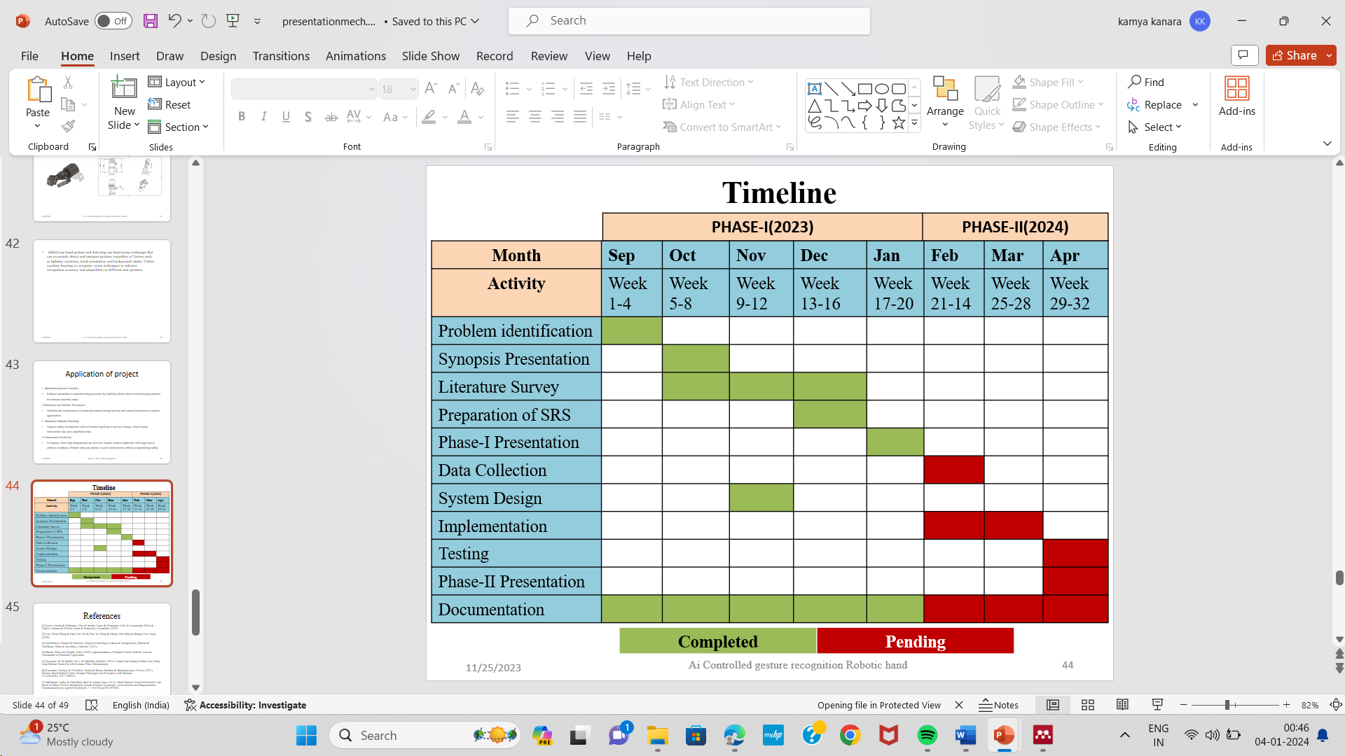

Fig. 4.1: Project Gantt chart

**CHAPTER 5**

**BUDGET**

Table 1project cost analysis

|  |  |  |
| --- | --- | --- |
| **Materials / Component** | **Dimensions/ specifications** | **Price ( in₹)** |
| Raspberry pi 4b + Accesories | Flash memory for program storage (2GB -8GB RAM,1.5GHzprocessor), Voltage levels vary between 3.3V and 5V | **8000** |
| Arduino | Arduino uno (14 digital pins and 6 analog pins) | **500** |
| 3D printed hand | MATERIAL=PLA | **3000** |
| Sensors | Infrared, Accelerometers, Gyroscopes, and Magnetometers | **1500** |
| Actuator(Servo motor) | Actuators(Servo motor) | **600** |
| Power supply | - | **0** |
| Pi camera with driver | (5MP,Resolution = 1080x720p) | **1000** |
| **Total** | | **15500** |

**CHAPTER 6**

**EXPECTED OUTCOMES**

**1.Gesture-Based Command Recognition**

* The robotic arm should be able to mimic the hand motion of the user
* The system should be intuitive allowing users to easily and naturallycommunicate with the robotic arm through gestures.
* It should recognize a diverse range of hand gestures to provide acomprehensive set of commands for controlling the robotic arm.
* Provide the ability to customize and expand the set of recognizedgestures based on specific applications or user preferences.

**2.Real-Time Motion Control:**

* Achieve low latency between gesture recognition and corresponding roboticarm movements to create a real-time and seamless interaction.
* Ensure that the movements of the robotic arm accurately represent the recognize hand gestures.
* Enable the system to adapt to different speeds and intensities ofgestures, allowing for precise control over the robotic arm's motions.

**REFERENCES**

[1] S. A. Hande and N. R. Chopde, “Implementation of Gesture Control Robotic Arm for Automation of Industrial Application,” *Int. J. Sci. Res. Sci. Technol.*, pp. 147–156, 2020, doi: 10.32628/ijsrst207442.

[2] M. Korayem, M. A. Madihi, and V. Vahidifar, “Controlling Surgical Robot Arm Using Leap Motion Controller with Kalman Filter,” *Measurement*, vol. 178, p. 109372, Apr. 2021, doi: 10.1016/j.measurement.2021.109372.

[3] E. Coronado, J. Villalobos, B. Bruno, and F. Mastrogiovanni, *Gesture-based Robot Control: Design Challenges and Evaluation with Humans*. 2017. doi: 10.1109/ICRA.2017.7989321.

[4] B. Jayasurya, J. Justin, C. Kharat Pooja, M. A. Hasaraddi, and T. Kavitha, “Gesture controlled AI-robot using Kinect,” *Studies*, vol. 2, p. 1, 2021.

[5] A. Chaudhary, *Robust Gesture Recognition for Robotic Hand Control*. 2017. doi: 10.1007/978-981-10-4798-5.

[6] K. Guo, M. Orban, J. Lu, M. S. Al-Quraishi, H. Yang, and M. Elsamanty, “Empowering Hand Rehabilitation with AI-Powered Gesture Recognition: A Study of an sEMG-Based System,” *Bioengineering*, vol. 10, no. 5, p. 557, 2023.

[7] J. P. Sahoo, A. J. Prakash, P. Pławiak, and S. Samantray, “Real-time hand gesture recognition using fine-tuned convolutional neural network,” *Sensors*, vol. 22, no. 3, p. 706, 2022.

[8] A. Haria, A. Subramanian, N. Asokkumar, S. Poddar, and J. S. Nayak, “Hand gesture recognition for human computer interaction,” *Procedia Comput. Sci.*, vol. 115, pp. 367–374, 2017.

[9] C.-H. Hung, Y.-W. Bai, and H.-Y. Wu, “Home appliance control by a hand gesture recognition belt in LED array lamp case,” in *2015 IEEE 4th Global Conference on Consumer Electronics (GCCE)*, IEEE, 2015, pp. 599–600.

[10] M. Yasen and S. Jusoh, “A systematic review on hand gesture recognition techniques, challenges and applications,” *PeerJ Comput. Sci.*, vol. 5, p. e218, 2019.

**PHOTO GALLERY**

**Photos of Bills-copy**

 